**✨MOTIVATION ✨**

Motivation is derived from the Latin word which means to move” or “to energize” or “to activate”.

Motivation 💖 (Learn at least 2)

* A process that arouses, maintains and guides behavior toward a goal. (Cacioppo & Freberg, 2013)
* It refers to all the internal conditions that stir up activity and sustain activity of an individual. (Guilford)
* The term motivation refers to the states within a person or animal that drives behavior toward some goals. (Morgan & King)
* An internal force to achieve goal.

**Need:** A motivating force that compels actions for its satisfaction.

**Drive:** A state of tension and arousal triggered by cues important for survival.

**Incentive**: A reward that pulls on organism’s behavior in a particular direction.

**Types of reward: 💖**

* intrinsic Reward: A type of reward that tends to give personal satisfaction to the individual e.g. feedback, acknowledgment. Internal motivation and is intangible.
* Extrinsic Reward: A concrete reward received by the individual from external environment e.g. promotions, money, fringe benefits, grades, wages, salaries. External and tangible

**MOTIVE**: Psychological state (perceived as a ‘need’) that moves us to engage on an organized set of behaviors that maximize the fulfillment of that motive. 😊

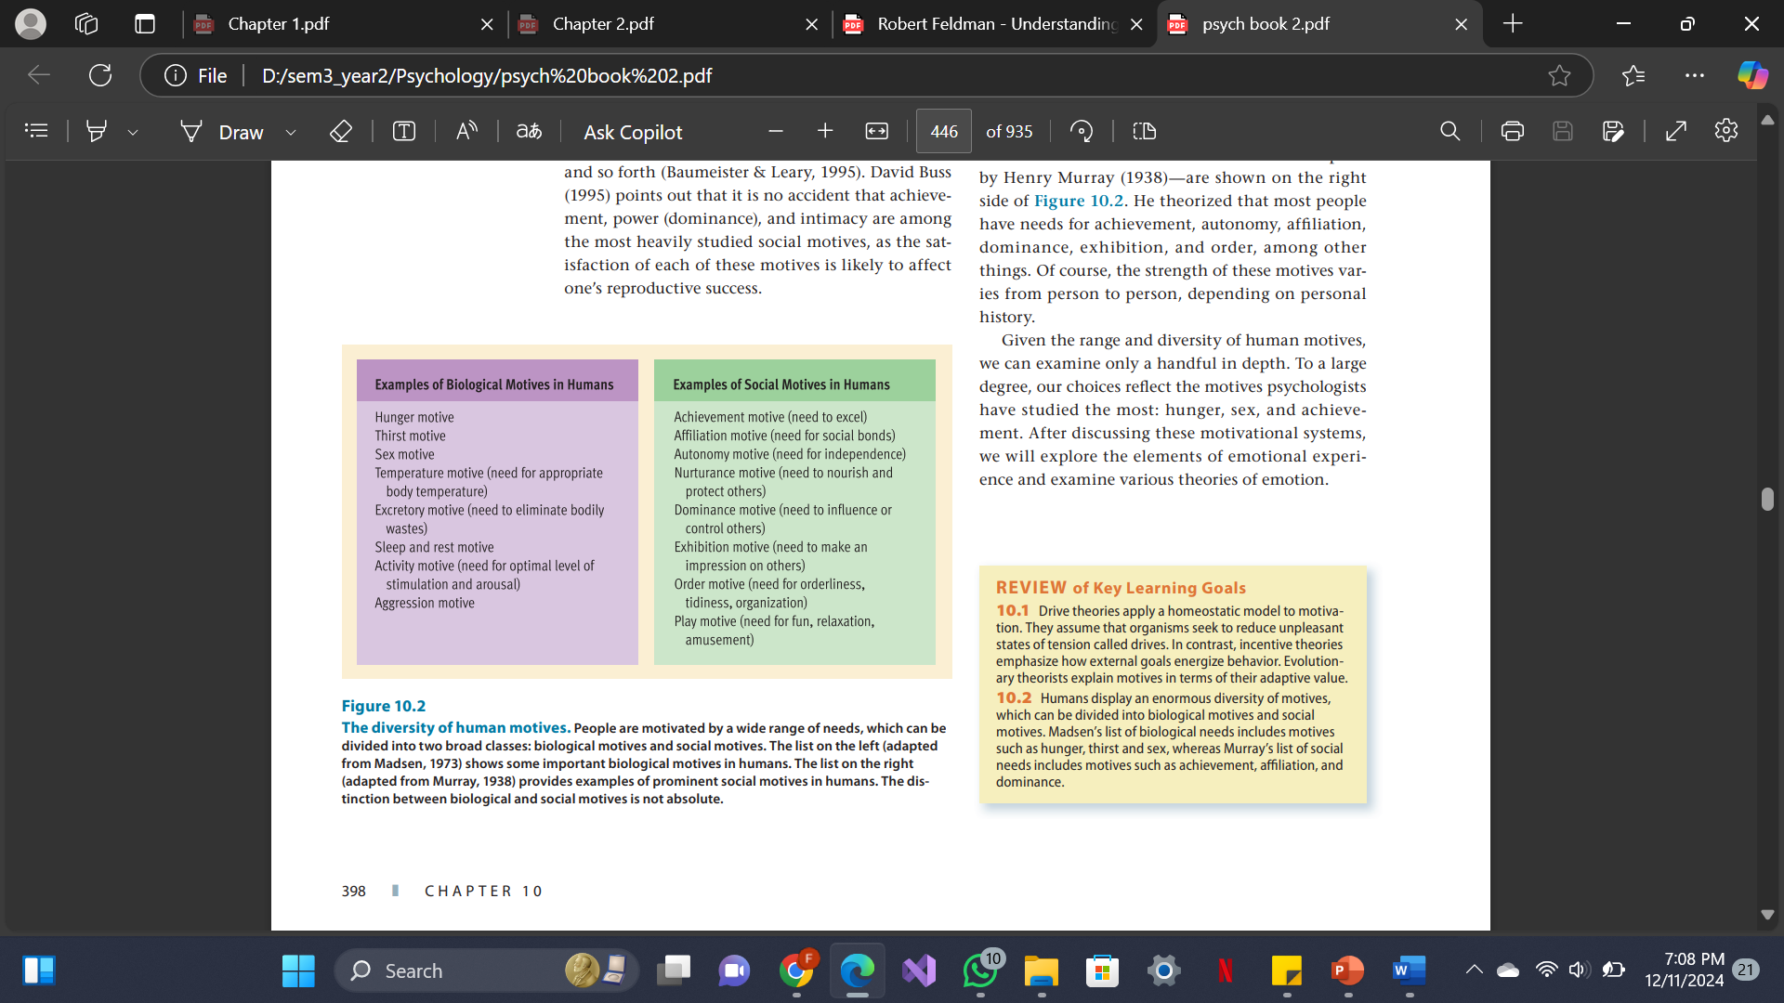

**Conscious and Unconscious**: Some motives are *conscious*, meaning we are aware of them, like studying hard for a promotion. Others are *unconscious*, meaning we act without recognizing the underlying drive, like being unconsciously motivated by a need for social approval.

**Approach and Avoidance Motives**: These define whether a motive is about moving *toward* or *away from* something. *Approach motives* drive us toward a desirable goal (like seeking happiness or success), while *avoidance motives* drive us away from an undesirable outcome (like avoiding failure or rejection).

**Variable and Constant**: Some motives are *variable*, changing based on circumstances (like motivation to eat varying with hunger). Others are *constant*, meaning they consistently influence behavior across situations, such as a long-standing desire for achievement.

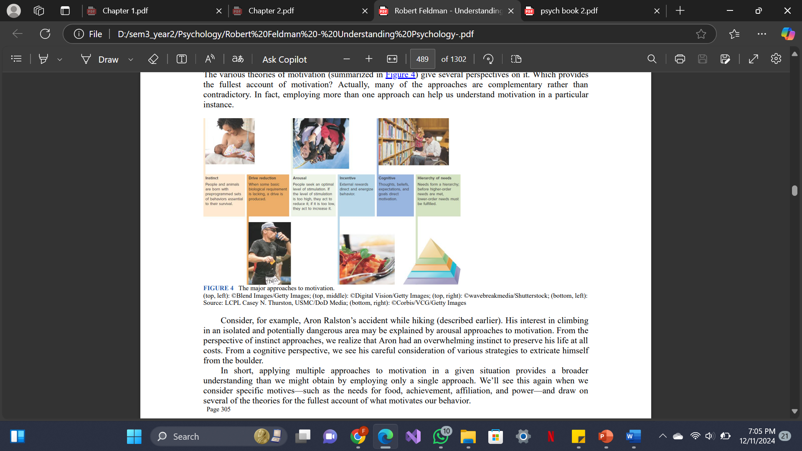

**Vroom’s Expectancy Theory of Motivation**

formula to calculate the motivational force: Motivational force = Expectancy x Instrumentality x Valence

**Expectancy** is the belief that effort leads to performance.

**Instrumentality** is the belief that performance leads to reward.

**Valence** is the value of the reward itself.

**Equity theory of motivation by Stacey Adams**

Adams Equity Theory, created by John Stacey Adams is about **fairness** in the workplace. It explains why **fair treatment** is just as important as pay and benefits for keeping employees motivated. Simply giving someone a raise or promotion may not always work if they feel that others aren’t being treated fairly.

The theory suggests that employees stay motivated when they feel their **efforts and rewards are balanced** compared to others.

1. **Inputs**: These are what employees bring to the job. Inputs include time, effort, experience, and skills.
2. **Outputs**: These are the rewards employees receive for their work. Outputs can be divided into:

**Financial rewards**: These are things like salary, bonuses, or profit-sharing. **Immaterial rewards**: These are things like recognition, responsibility, and challenging work.

* **Fair Treatment**: If two employees do the same job, but one receives a higher salary without putting in more effort or skill, the other employee might feel demotivated. Cause frustration and demotivation
* **Recognition and Responsibility**: Imagine an employee who consistently shares ideas and helps coworkers but is never given credit or new responsibilities. This employee might feel that their input isn’t being valued, even if they’re paid well. Without recognition, they may feel undervalued and could lose motivation.

**Primary Motives:** Motives which are linked with basic primary needs and associated with biological well being of an individual….Need for food, water and oxygen, Needs that are fundamental for survival. Need to take rest when tired. Need for being active when rested.

**Secondary Motives**: Motives linked with one’s socio-psychological needs are known as secondary or psychological motives. Need for freedom, security, achievement, affection, recognition, companionship and self actualization

Motivation cycle: need → tension →activity →motivated behaviour →reduction of tension →achievement of goal → satisfaction → need again(loop never stops)

**Natural/Intrinsic Motivation**: The task itself is enjoyable and motivating eg: reading poetry brings you joy

**Artificial/Extrinsic Motivation**: The task is a means to an external reward, not inherently enjoyable.

**McClelland's Theory of Needs ("Three Needs Theory" or "Learned Needs Theory")**

**Achievement (nAch)**: The need to excel, to achieve goals, and to accomplish tasks. People with a high need for achievement are motivated by the desire to improve themselves and to attain challenging goals.

* **Avoidance of Low-Risk Situations**: Achievers tend to avoid tasks with low risks because success in such situations does not feel fulfilling or indicative of true capability. They crave challenges that reflect their skill and determination.
* **Avoidance of High-Risk Situations**: Conversely, they also avoid extremely high-risk scenarios because the outcome feels too random, where success could be attributed to luck rather than personal effort.
* **Need for Feedback**: Achievers need regular feedback in order to monitor the progress of their achievements. They prefer to work alone or with other achievers.

**Affiliation (nAff)**: The need for social interaction, relationships, and a sense of belonging. Individuals high in affiliation seek approval and are motivated by the desire to maintain positive interpersonal relationships.

* Those with a high need for affiliation (nAff) need harmonious relationships with other people and need to feel accepted by other people.
* They tend to conform to the norms of their work group.
* High nAff individuals prefer work that provides significant personal interaction.

**Power (nPow)**: The need to influence and control others. This need can manifest in different ways, such as a desire for personal power (to lead and influence others) or institutional power (to make a difference within an organization).

* Those who need personal power want to direct others, and this need often is perceived as undesirable.
* Persons who need institutional power (also known as social power) want to organize the efforts of others to further the goals of the organization.

**Maslow’s Theory of Self Actualization**

Behaviour of a person is always dominated not by his satisfied needs but by his unsatisfied wants, desires and needs.

